Application Form: Liz Hughes Award for Her Farm Radio
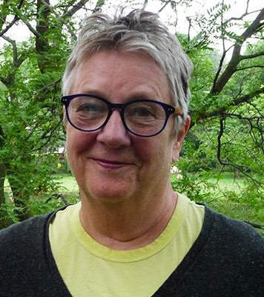
This award recognizes radio stations and producers who are dedicated to serving women listeners. Their radio programs address and advance gender equality. They may share the experiences and opinions of women, or address issues of concern to women. Farm Radio International developed this award in memory of board member Liz Hughes.

In rural sub-Saharan Africa, women play an important role in farming, family, and the community. Yet they are more likely to experience extreme poverty, malnutrition, and poor health. They are also likely to have less access to and control over resources, including information. It is essential that radio programs serve the needs and interests of women as well as men. In this way, both women and men can benefit from the information shared, and have the potential to contribute to community development.

Learn more about gender equality issues in land rights in this backgrounder.
Learn more about how to serve women farmers well in this Broadcaster how-to guide.

Station Details:

Name of Station: _______________________________

Country: _______________________________

City/Region: _______________________________

Email: _______________________________

Phone number: _______________________________

Program Details:
Name of program: ______________________________

Focus of program: ______________________________

Duration: ______________________________

Time/Day of broadcast: _______________________________

List all the staff involved in producing and broadcasting the program, including their gender. This may include manager, producer, host, presenter, reporter, technician.

Name | Role | Gender (M/F)

Please attach examples of a typical program lineup / runsheet as a Word document or a PDF.

Main Application:

- What is the purpose of the program? Who are you aiming to serve and why?

- How does this program serve women listeners? Please tell us what topics you discuss. How do you ensure that your program promotes the many roles of women?
You may share an anecdote that shows local gender stereotypes and how your program has tried to address these. For example, do you talk about men and women in non-traditional roles? Do you talk about women growing cash crops, women as leaders, or men’s contribution to health and nutrition?

- How do you address gender equality?
Please tell us about how your program addresses women’s rights, the role of women in decision-making, women’s access to and control of information, etc.

- How do you produce the program to meet these objectives?
Please describe how you include women and women’s issues in each step of planning and producing your program. For example: How are women included in the planning process? Do you have a woman host? Do you consult women experts?

- Describe how women’s and girls’ voices are included in the program. What steps do you go through to collect the voices of your women listeners?
(For example: through vox pops, in-station interviews, Uliza polls, panel discussions, field recordings, etc.)

- What challenges have you faced while producing this program? How did you overcome these challenges?
If possible, please pick an example that shows your effort to advocate for gender equality. For example, has it been challenging to engage women in the radio program? Has it been challenging to find female experts to interview? Have you had difficulty discussing certain sensitive topics on air?

- Describe any changes in your community since airing the program.
For example, what feedback have you heard from listeners? Have you had any impact at the household or community level? Has there been a change in the roles and responsibilities of women?

8. You must include an MP3 recording of an episode of your program. We understand that you likely broadcast in a local language, so please provide a short summary of the episode. Please include information on the topics discussed, who was interviewed, and the ideas shared.

