Application Form: Liz Hughes Award for Her Farm Radio
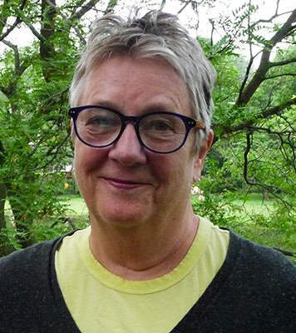
In memory of Farm Radio board member Liz Hughes, this award recognizes radio stations and producers who are creating radio programs that serve their women listeners. These programs address and advance gender equality. They may share the experiences and opinions of women in a unique way, or address issues of concern to women.

In rural sub-Saharan Africa, women play a vitally important role in farming, family, and the community. Yet they are more likely to experience extreme poverty, malnutrition, poor health, and have less access to and control over resources. It is essential that radio programs serve the needs and interests of women as well as men. In this way, both women and men can benefit from the information shared and have the potential to contribute to community development.

Learn more about how to serve women farmers well in this Broadcaster how-to guide.

Station Details:

Name of Station: _______________________________

Country: _______________________________

City/Region: _______________________________

Email: _______________________________

Phone number: _______________________________

Program Details:

Name of program: ______________________________

Focus of program: ______________________________

Duration: ______________________________

Time/Day of broadcast: _______________________________

List all the staff involved in producing and broadcasting the program, including their gender. This may include manager, producer, host, presenter, reporter, technician.

Name | Role | Gender (M/F)

Please attach an example of a typical program lineup as a Word document or a PDF.

Main Application:

- What is the purpose of the program? (Who are you aiming to serve and why?)

- What are the objectives of the program in terms of gender equality? How do you serve women listeners? How do you share the voices of rural women? (Approximately 100 words)

- How is the program (segments, features, formats, etc) produced to meet these gender equality objectives? (Approximately 100 words)

- Describe how topics are chosen for each episode, and how you consider gender issues. (For example: By following local/national/global news, consulting with listeners, talking to a gender expert) (Approximately 100 words)

- What challenges have you faced while producing this program? How did you overcome these challenges? (Approximately 100 words)

- Describe how women and girls’ voices are included in the program.
(For example: through vox pops, in-station interviews, Uliza polls, panel discussions, field recordings, etc.) (Approximately 100 words)

- Describe any changes in your community or in the communities of your listenership since airing the program. Have you received any feedback from listeners? (Approximately 100 words)

- Please attach an MP3 recording of the best episode of the program with your application. Describe the topics that are being discussed in this recording. (Approximately 50 words)

